Objects and Classes

Classes and objects are fundamental concepts.
- A class is a category or type of “thing”, often referred to as a template or blueprint.
- An object belongs to a particular class.

Consider the word “chair”. It is ambiguous, but if we are talking about chairs in general, we can consider it a class. All chairs are made for sitting, have legs, a seat, etc.
Consider specific chairs. Some chairs might have a specific colour, a specific amount of legs, a specific seat. We consider specific chairs as objects.
For every class, there can be many objects. A class can have sub-classes. For example, the superclass car can have sub-classes for each manufacturer.
- Abstraction is the idea of putting real world examples into classes and objects.

Objects have operations which can be invoked (Java calls them methods).
- Methods may have parameters to pass additional information needed to execute.
  - Parameters introduce variation into the effect of method calls.
- Many distinct instances can be created from a single class.
- An object has attributes: values stored in fields
- The class defines what fields an object has, but each object stores its own set of values (the state of the object)
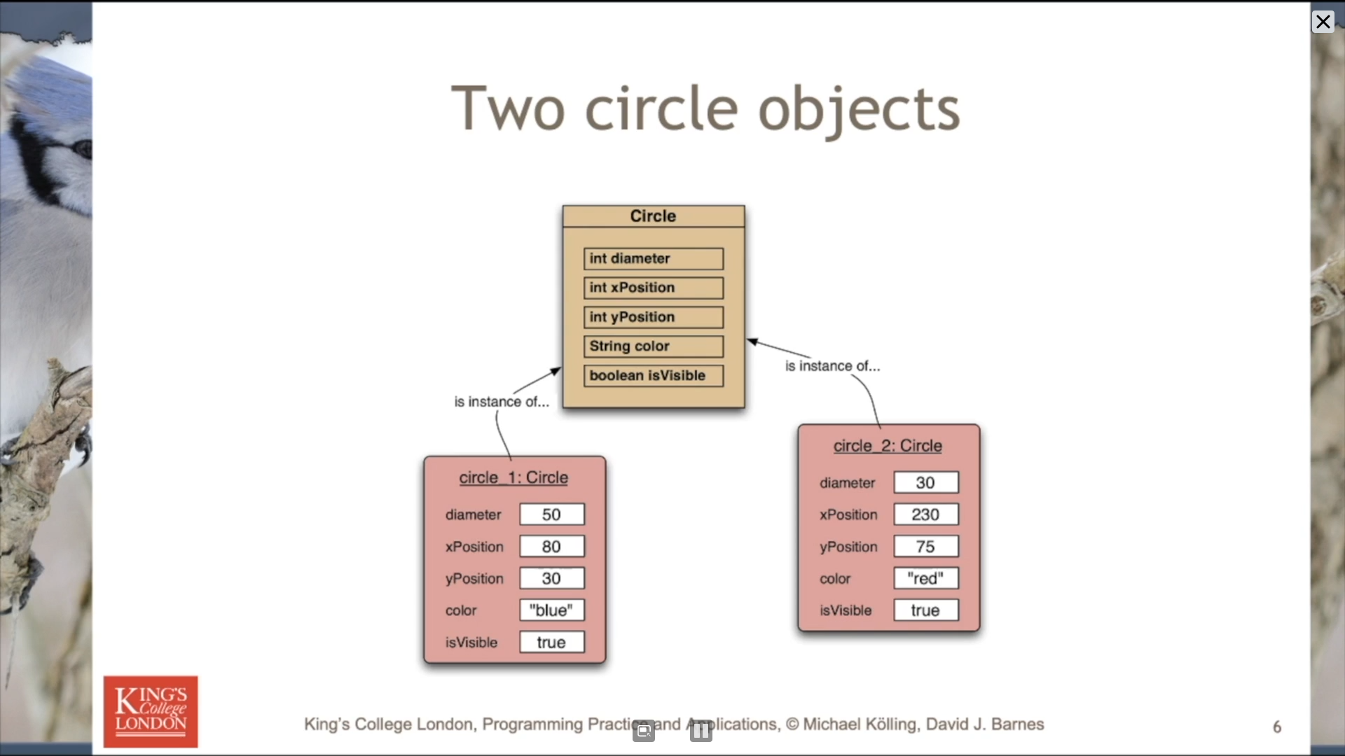

Each class has source code associated with it that defines its details (attributes and methods).
- The source code is written to obey the rules of a particular programming language.
Most methods have void return types, but methods may return a result via a return value. Such methods have a non-void return type.

In summary…
- Classes model concepts.
- Source code realises those concepts.
- Source code defines:
  - What objects can do (methods).
  - What data they store (attributes).
- Objects come into existence with pre-defined attribute values.
- The methods determine what objects do with their data.
- When a method is called, an object:
  - Alters its state, and/or
  - Uses its data to decide what to do.
- Some methods take parameters that affect their actions.
- Methods without parameters typically use their state to decide what to do
- Some methods return a value.
- Most programs contains multiple classes.
- At runtime, objects interact with each other to realise the overall effect of the program.

